INTRODUCTION
Overview
Retailing encompasses the business activities involved in selling goods and services to consumers for their personal, family, or household etc. A CRM product owner has requested to create two applications, one is a sales app for sales reps to use this application and store customers data, and the second application is a service app for service reps/agents to provide support to customers in dealing cases. To generate business on top of the customers.
Purpose
This Project helps in managing the customer details in one place
The use of this project. What can be achieved using this.
A CRM product owner has requested to create two applications, one is a sales app for sales reps to use this application and storecustomers data, and the second application is a service app for service reps/agents to providesupport to customers in dealing cases. To generate business on top of the customers.
- Problem Definition & Design Thinking
Empathy Map
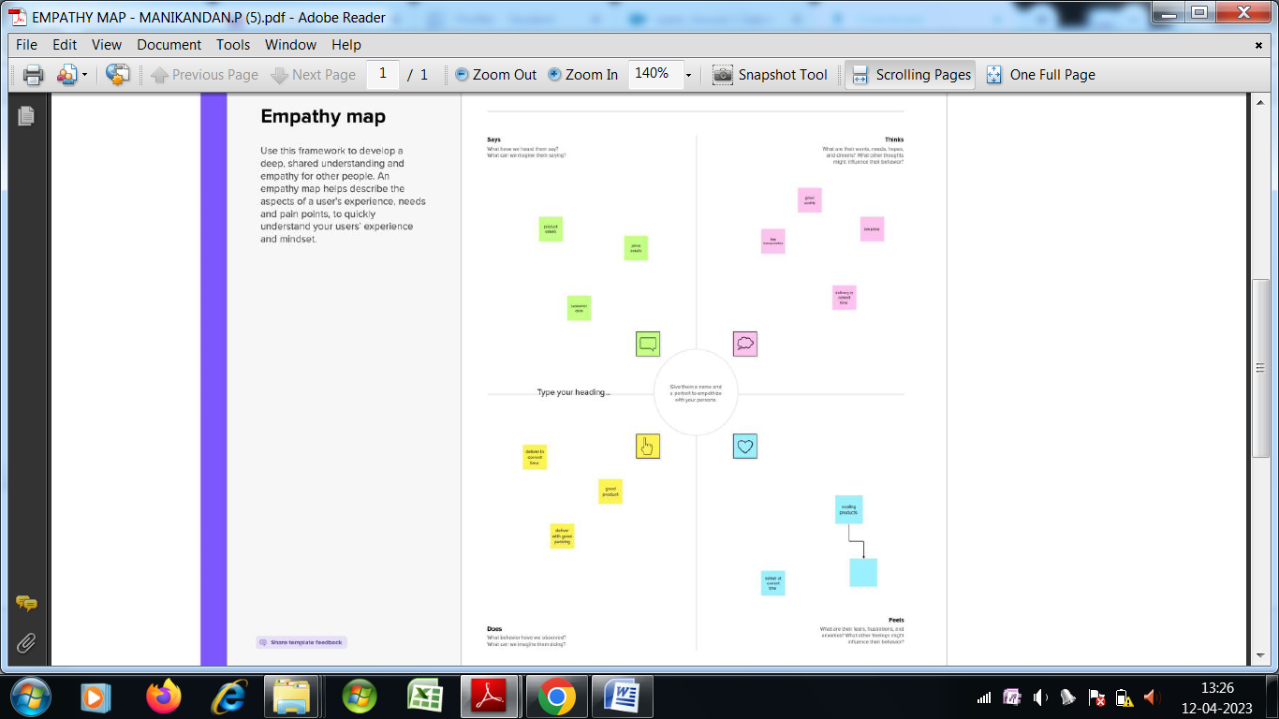

Paste the empathy map screenshot
Ideation & Brainstorming Map

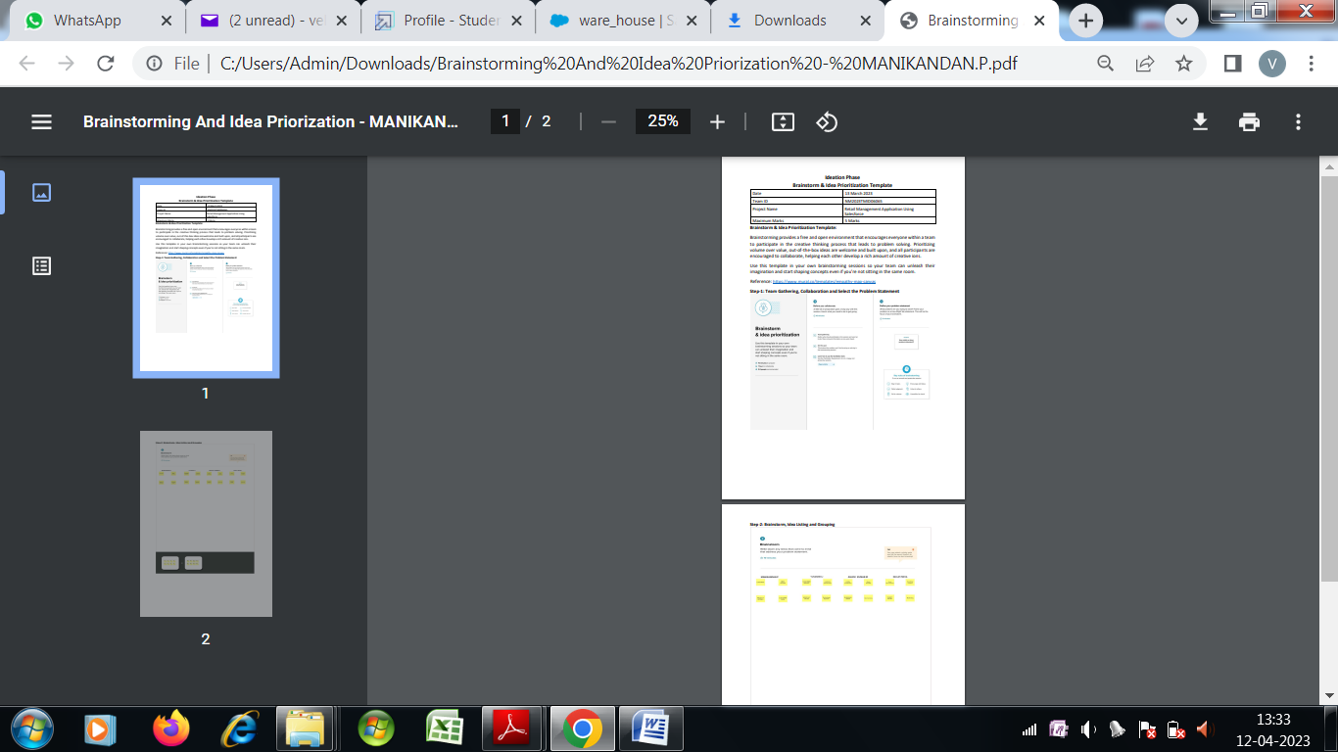

RESULT

Data Model:
Field label | Data type
Company name | Text
Owner | Text

Object name | Fields in the Object
obj1
Campaign
obj2  Accounts
  Field label | Data type
  API name | Text
Obj 3  Contacts
  Field label | Data type
  Name | Text
  Phone number | Number
Obj 4
Case

Activity & Screenshot
Field label | Data type
Name | Text
Title | Text

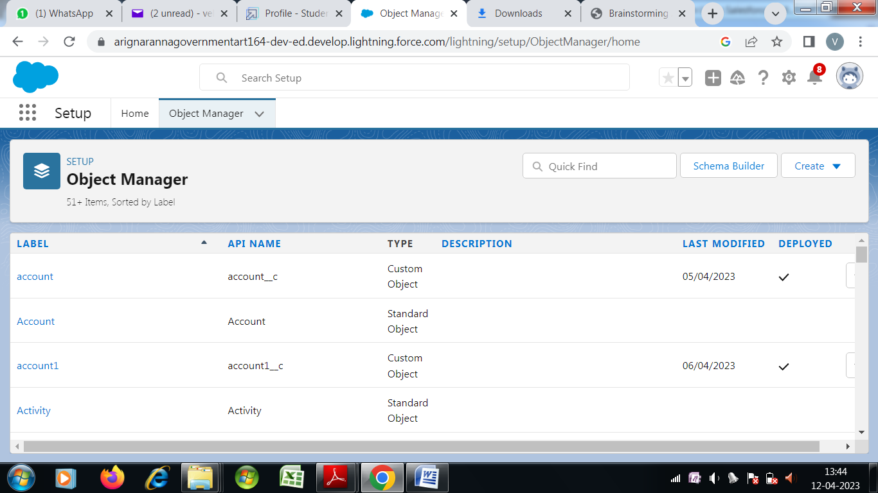
Attach the screenshots of your project activity along with the description.

Trailhead Profile Public URL
Team Lead https://trailblazer.me/id/manip67
Team Member 1 -https://trailblazer.me/id/dhild20
Team Member 2 -https://trailblazer.me/id/yyuvanesh
Team Member 3 -https://trailblazer.me/id/akumar8297

ADVANTAGES & DISADVANTAGE
List of advantages

- We can store large number of customer data
- We can manage things details as well as sales details
List of disadvantages
- Privacy of customer data is difficult one.

APPLICATIONS
- Retailing encompasses the business activities involved in selling goods and services to consumers for their personal, family, or household etc
- CONCLUSION
This Project helps in managing customer data as well as selling details using salesforce

FUTURE SCOPE
It can be developed in different languages and pictorial basis even for understanding uneducated peoples

